A Minor Project Mid-term

Report on

“**Blood Management System**”

Submitted in Partial Fulfillment of the Requirements for the Degree of Software engineering

Under Pokhara University.

Submitted by:  
**Himshikha Rai(15756)**

**Denis Gurung(15755)**

Under the Supervision of:

(Mr. Er. Amit Srivastava)

………………….

Date:  
(12th Dec,2018)



**Department of Software Engineering**

**NEPAL COLLEGE OF INFORMATION TECHNOLOGY**

Balkumari, Lalitpur, Nepal

Title Page

# Acknowledgement

# Abstract

Releasing the need of the management of bloods that are donated we have entitled the name "Blood Management System" for our sixth semester project. The blood received from the donation events needs a proper and systematic management. We are having a problem finding a matching blood whenever we need the blood. And it is quite troublesome to contact every hospitals checking for the blood. Thus, the Blood Management System will provide the details regarding the availability of blood in hospitals.

Blood Management System is a disciplinary action to provide the proper evidence for the patient who need the blood. This system is a means to connect the donors and the patients. There are numbers of web based applications to provide the communications regarding the details of availability of blood. Manual systems are costly, time consuming and laborious than electronic based blood management systems.

Keywords: Management System, Blood Bank

Table of Contents

1.TITLE PAGE 2

2.ACKNOWLEDGEMENT 3

3.ABSTRACT 4

4.TABLE OF CONTENT 5

5.LIST OF FIGURES 6

6. INTRODUCTION 7

6.1 PROBLEM STATEMENT 8

6.2 OBJECTIVES 9

6.3 SIGNIFICANCE OF STUDY 10

7. METHODOLOGY 11

8.LITERATURE STUDY/REVIEW 13

9.DETAILS OF OUR PROJECT 14

10.CONCLUSION 1

11.FURTHER WORKS/RECOMMENDATIONS 19

12.BIBLIOGRAPHY/REFERENCES 15

# List of Figures

# Introduction

"Blood Management System" is a mobile application that is developed to provide the easiest platform or field to connect or have a communication between the donors and the people who are in need of blood. This application contains two languages i.e. English and Nepali. The user can use any language based on their compatibility. User can register themselves whenever they want to donate a blood through the donor registration form provided and can search for the blood whenever needed. Information technology can greatly help the proper and smooth workflow of the medical facilities.

The blood management information system provides the functionalities to access or get the information regarding the donors from difference/various parts of the country. We also can easily find the required blood group donors who can help us when we are needy. It also helps in monitoring or reminding the donation camps being held and can also search for the lists of the hospitals or the blood banks available.

# Problem Statement

The system which is manual can be quite complicated for recording every information's and details about the donors, members, blood groups, addresses, etc.

This makes the maintenance of schedule erroneous.

There are lots of limitations of manual system which are listed below:-

* It is time consuming.
* It is quite laborious.
* The records can be error prone.

Thus to overcome this limitations the blood management system is needed whose main propose is to save user's time and to provide the user simplest and fastest application. To use the application the user does not have to remember or understand anything. The user can use the application easily.

# Project Objectives

The main aim and objectives of this project is to provide platform for the people to search the availability of blood whenever needed.

The goal of this project is to save users time for searching and contacting the entire hospital for availability of blood. It's objective is to maintain the Blood Bank Information System and to keep all information regarding the donors/users details, information who wants to donate the blood.

The following are the measure objective of this project:-

* To design an electronic blood donor management application.
* To develop the application through which we can reduce the human efforts.
* To record the information's such as blood request details, blood donor details, compatibility details.
* To also bring the donor and the patient in a common platform.
* To provide the means to advertise the public about the donation programs.

## Significance of the study

Researcher has developed the management information system for blood bank at Jhalawar district Rajasthan. Unfortunately blood bank staff still using the old traditional method i.e. they are maintaining the data manually. This practice effect the retrieval of the information and staff is unable to maintain the inventory properly. During the development of the management information system for the blood bank researcher focused on two concepts which are inventory control and the information retrieval. By developing the information system inventory should be properly managed and the information retrieval can be precise.

This system will provide three beneficiaries i.e. the first benefit will be to the donor, second the seekers and the blood bank. Donors can view the blood donation camp organizing at the different places and can also get the notification when his blood gets used. Seeker can get the information of the particular blood group available in the particular hospital. Blood bank in charge is getting rid from manual procedure. Now they to do the entries in the information system. The probability of error should be minimal. Information retrieval should be precise and effective

## Methodology

Every project has methods or plan to implement the project. Thus our project methodology will be as follows:

A) Software Development Life Cycle:

The framework we will be using for developing this project is Increment model along with agile techniques. This model combines linear sequential model with iterative prototype along with user's story and prototype model. When each increment is developed new functions will be added. There are four phases of Linear sequential model which are: Analysis, Design, Coding and Testing. The software is passes though phases, an increment and increment repeatedly for the progressive changes.

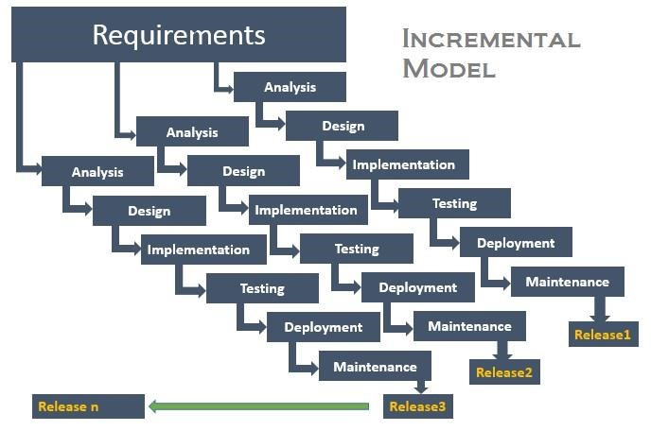

Fig 1: Incremental model.

I) Analysis phase:

In this phase, we find out the requirements of our software system. The outcome of this phase is called "System Requirement Specification".

II)Design phase :

We translated the SRS(System Requirement Specification) into the design. In other words we design the UML diagrams like Use-case diagram, Object diagram of our system.

III)Coding phase:

In this phase, we did the coding as per our design we designed in design phase. Implementation of project is done.

IV)Testing Phase :

In this phase, the system will be tested. With each testing a list of changes to the system developed, is suggested and the changes will be applied to the software and the software would be delivered as a successive increment until a satisfying system is achieved.

## Literature review

This section includes the literature review of web-based navigation and connecting portal service.

* Review

As the increasing use of technology and advancement in the technology, nowadays everyone wants to complete their tasks using digital devices. Along with many people now uses virtual platform to be connected, share and get genuine information. Social media is what most applied to day to day life of every person. Even though the advancement of this much technology, there lacks some sorts of services that every people are unable to use and benefit. Hence, our project would provide a people the platform for a people.

* Study

This is a android application system which is database application and is to be used by the patients and donor so that they can have the we based communications. It is also to advertise the donor and the people about the donations events being held. This system keeps the records of all the blood donors and recipients. Thus, this system intends to make the people grow along with the advancement in technology.

* Features not provided

Our project may not be a complete blood management system as it is only specific to particular hospital. It will not be able to give the details of all the hospitals.

## Details about our project

As I have already mentioned, our project is an android application whose propose is to provide the common platform to the donor and patients. The figures of our project we have done is shown and discussed below:-

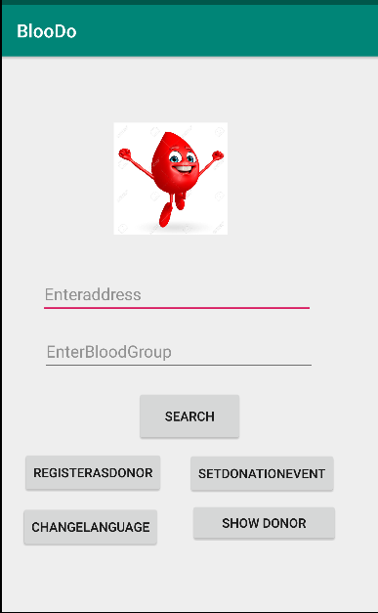

Figure 1:Main Page

This is the main layout of our android application and this layout will pop as we run our project.

## 

Figure 2:Registration

Form

## This is the registration form we have designed and the user can register themselves as the donor if they want to. Through this form they will be registered as donor and their information will be saved.

## 

Figure 3: Database register

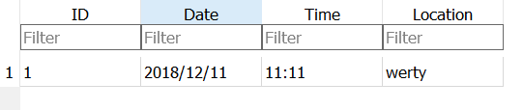

Figure 4: Database donation

## Figure 3 and 4 shows the databases of register and donation. Register database contains the list of the user that have registered as donor. While the donation database contains the list of donation event going to be held.

## 

Figure 5: Choose Language

## This is the layout that allows user to choose the appropriate language they are familiar with. This is one of the main feature of our application as user can use the application according to their language.

## 

Figure 6: Push Notification

## This is the push notification that our application will send to the donor when the new donation event is set. This feature will allow the user to know about the donation events about to happen so that they will not miss.

## Conclusion

## Further Works/Recommendations

## Bibliography

[1]"en.wikipedia.org

[2]''https://www.google.com/

[3]" <https://www.sciencedirect.com/>

## 